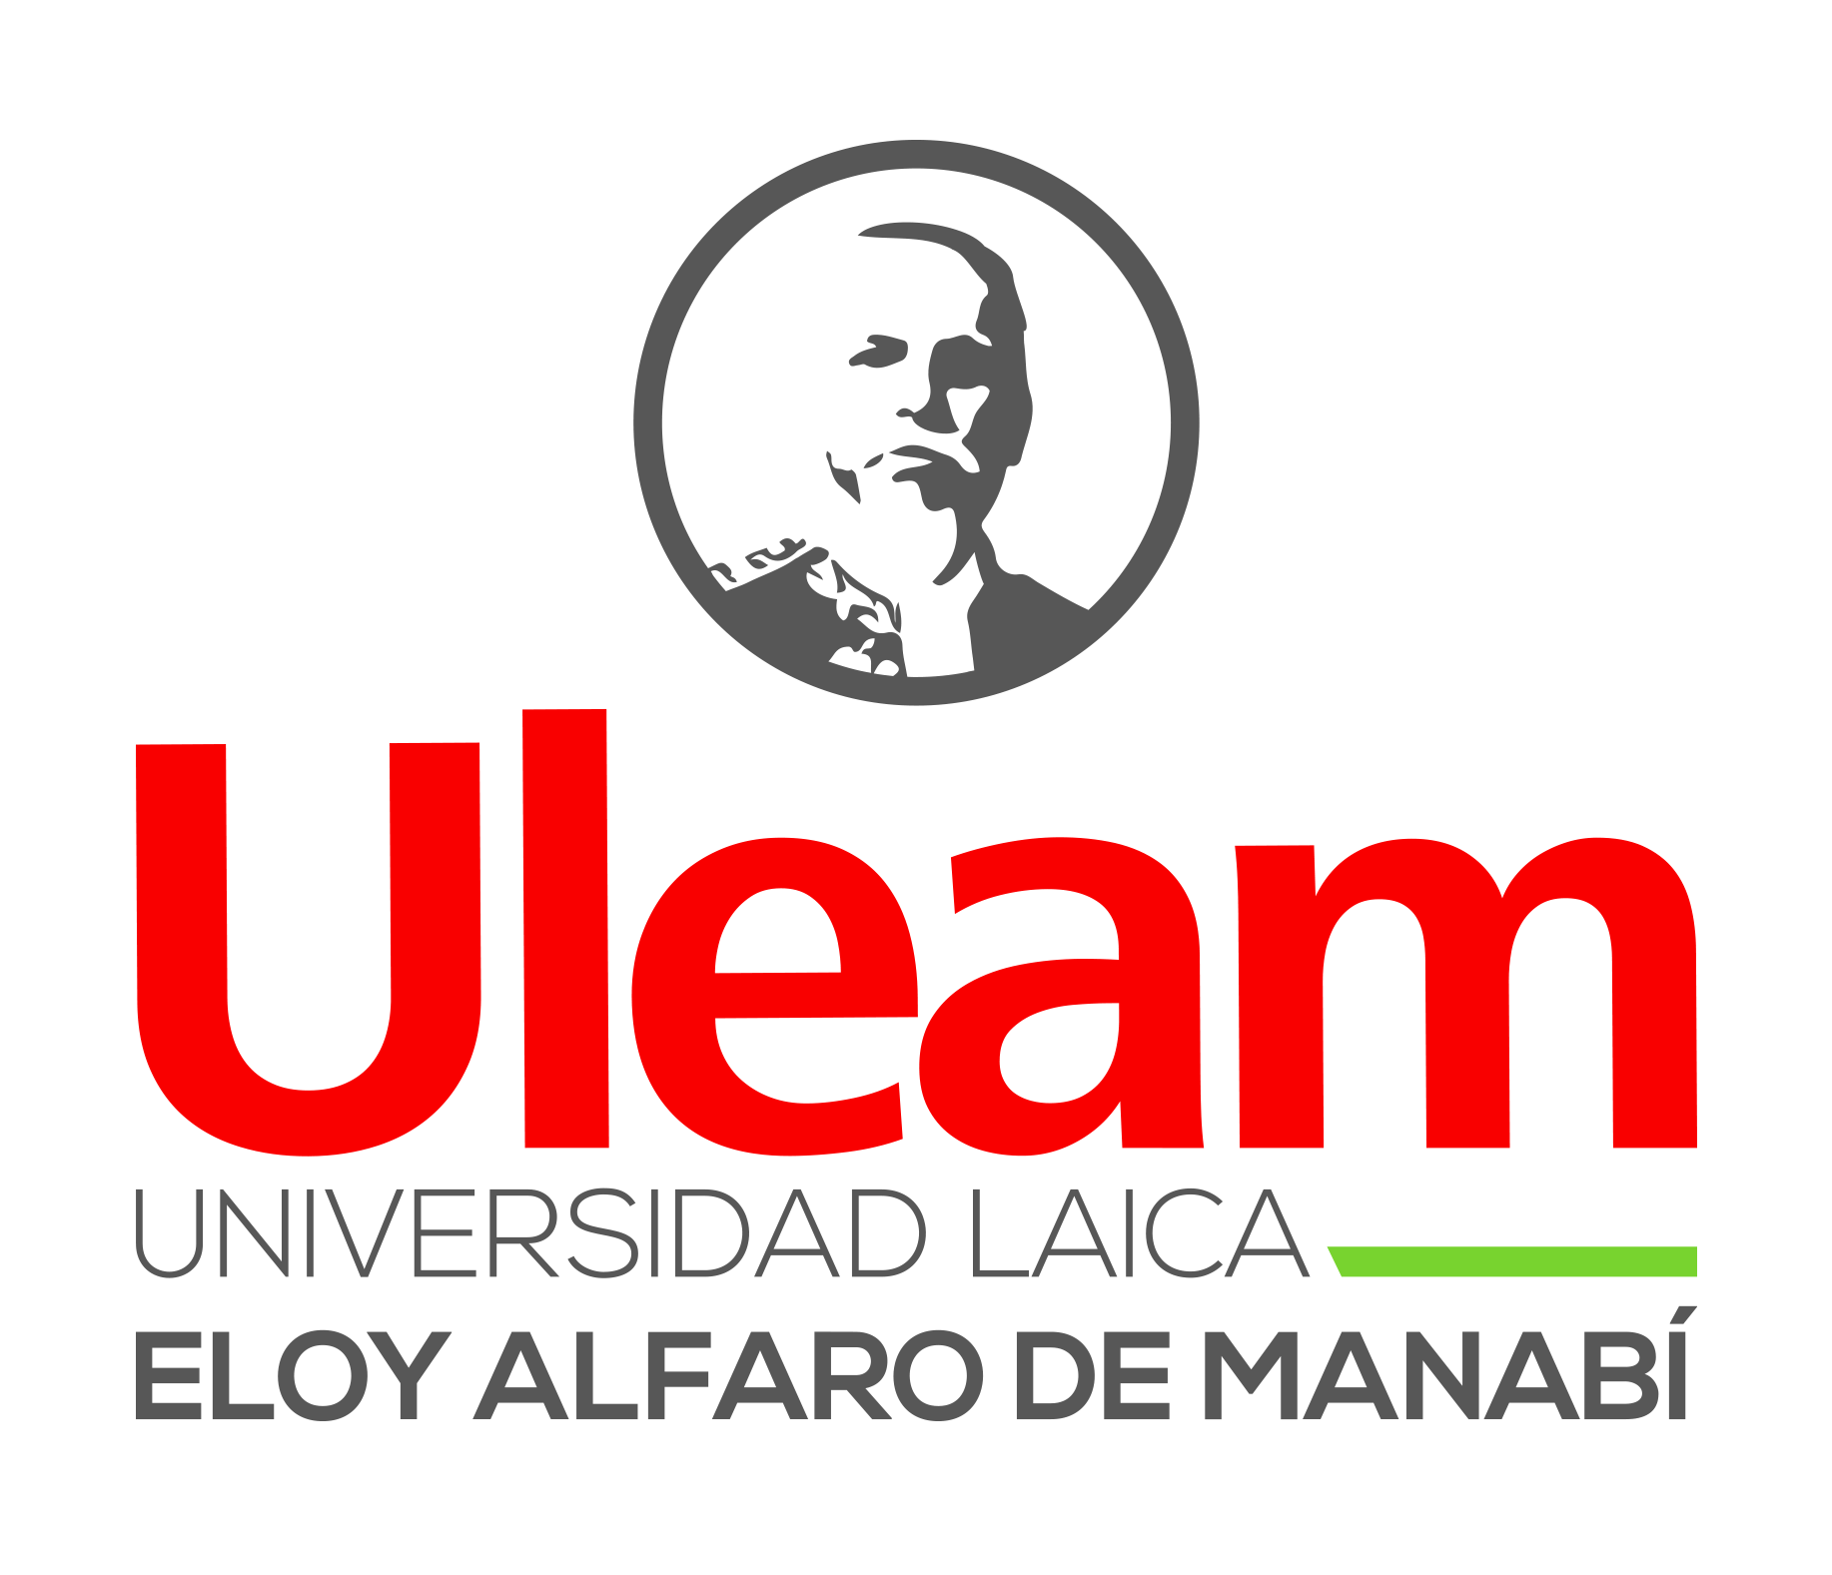
UNIVERSIDAD LAICA ELOY ALFARO DE MANABI
EXT – EL CARMEN

AI Assignment 02: Exploring Real-World AI Tools

Objective
Students will research cutting-edge Artificial Intelligence tools available in the real world. They will explore how these tools work, and how they are transforming industries such as education, creativity, software development, and more.
The goal is to understand real-world impact, and communicate findings clearly.

Activity Description
Students will explore what AI tools are currently available and how they are used in practice. For example:
- ChatGPT helps users generate natural language, answer questions, and brainstorm ideas.
- Midjourney creates stunning artwork based on text input using AI image-generation techniques.
- GitHub Copilot assists developers by auto-completing code with the help of machine learning.
Each student will search for at least three different AI tools, ideally from different domains (e.g., education, media, software, health, creative arts).
Research Each Tool Thoroughly
For each tool, answer the following:
Research Questions
What does the tool do?
Who developed it and when?
What technology or AI model powers it? (e.g., GPT, diffusion, transformers)
What are the key features and user experience like?
In which industries is it used?
What are its benefits and limitations?
Any ethical or privacy concerns?

By: Cesar Sinchiguano

